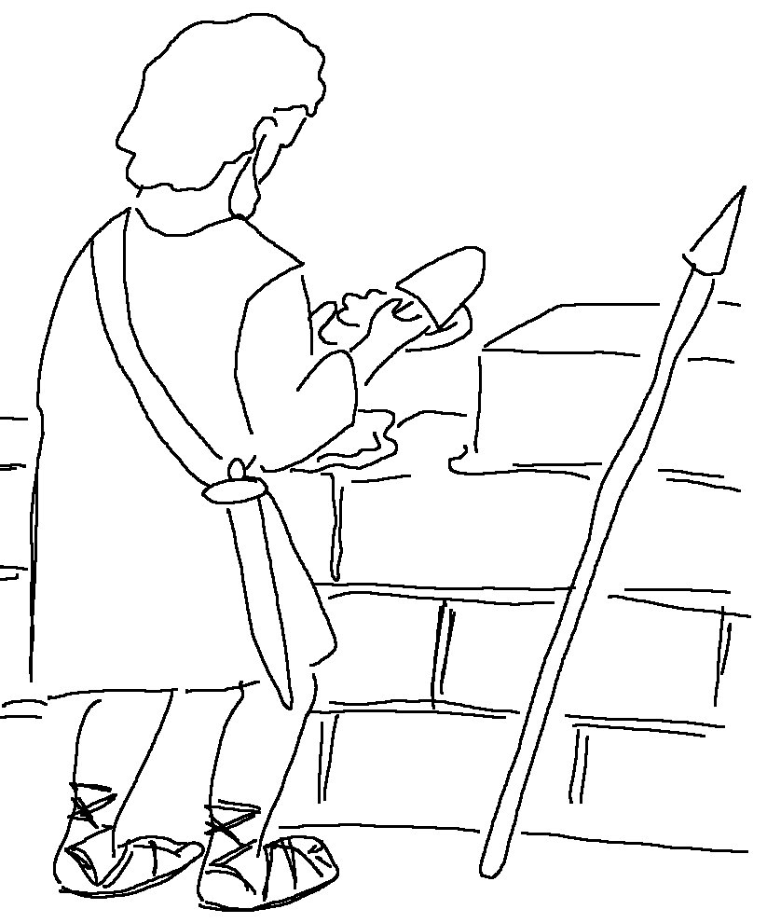
We are _ _ _'s fellow _ _ _ _ _ _ _.
1 Cor 3:9 _{NLT}

